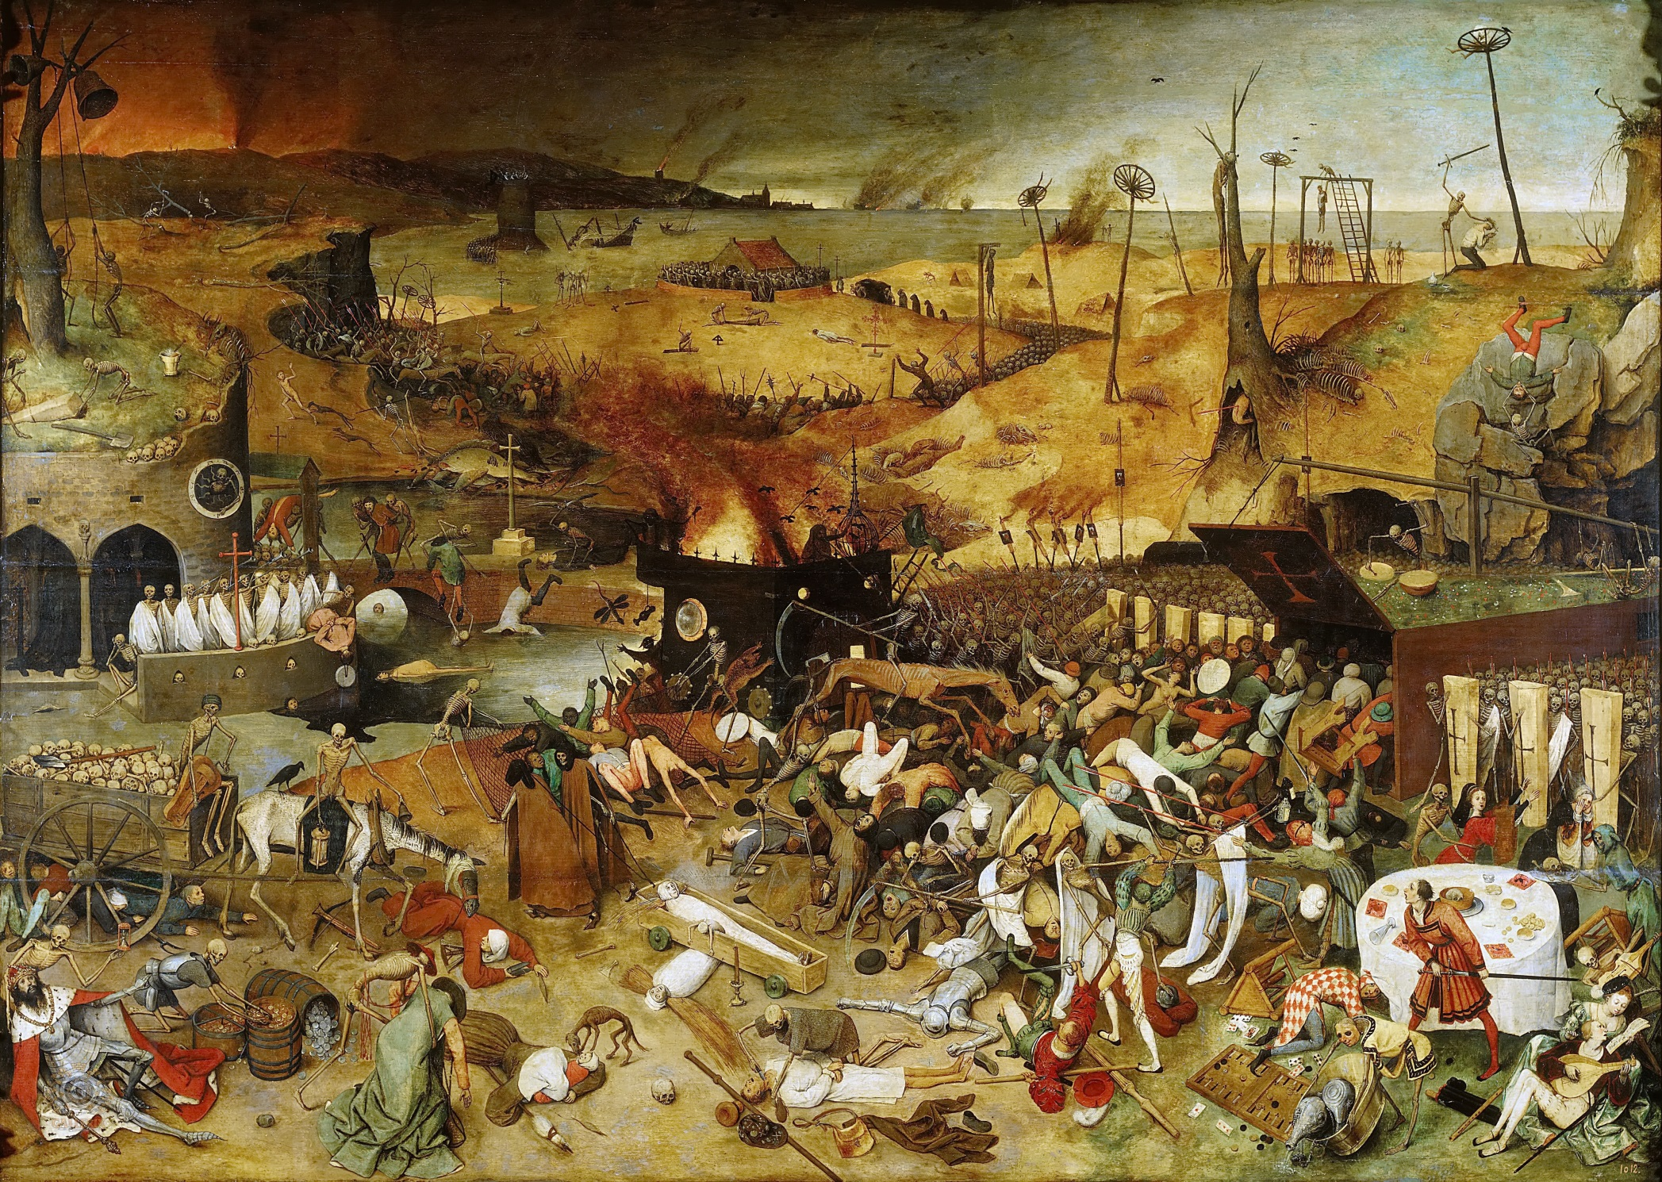
The “Triumph of Death” Questions

- What do you think the artist is trying to portray with this painting?

- What is the difference when you compare the foreground to the background?

- What figure in the painting represents Death (and where is it located)?

- List 5 descriptive themes that you see in this painting.

- How do you know that the Black Death does not discriminate

Triumph of Death
» Pieter Bruegel the Elder (Netherlandish, c. 1525–1569)

Painted by Bruegel around 1562, this apocalyptic work known as the Triumph of Death depicts the end of all life on earth.
Because of the high horizon, Bruegel is able to present a broad vision of death and destruction. Two narratives are enacted in the horrific scene. The larger narrative shows Death, in the form of a skeleton, riding on a pale horse through the middle-ground, leading an army of executioners to bombard and kill the masses of humanity.
Details within this chaotic scene illustrate a second narrative. Along the foreground of the painting, individuals representing different stations in life—including a king, a cardinal, chess players, a loving couple, and a knight—are slaughtered. Only one finely dressed figure in the right foreground draws his sword to fight back Death. One by one these prominent individuals, along with the anonymous masses, fall prey to Death, who does not discriminate. This kind of imagery is reminiscent of the medieval series known as the Dance of Death.
Death’s horrors, similar to the visions presented in Bruegel’s Triumph, were familiar to the citizens of Antwerp at mid-century. Religious wars with the Spanish ended the peace and prosperity of the southern Netherlands at this time.

Compare
