Unit 7: Global Depression – Causes and Impacts
Credit Expands…Dangerous!
During the 1920s, ________________ (giving loans to be paid back at a later date) greatly _____________________with the risk that if the economy got worse, people would not be able to pay it back!
More and more people relied on credit even to purchase ______________, hoping the stock prices would rise and they could pay back their credit…what if prices don’t rise???

US Dominates the World Economy!
After WWI, the ________ dominated the _______________ ____________ because _________________ was in debt and recovering from the war.
America increased its _________________________ to provide goods to Europe and grew _________________ as a result!
- This time period was called:
“ ”

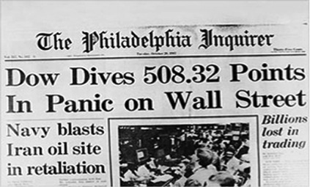
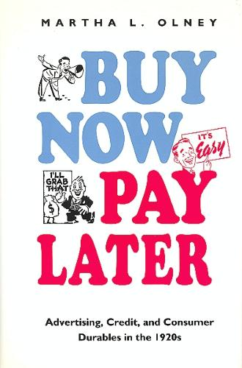
Black Tuesday
October _____^{th}, 1929: Stock Market crashes!
- Value of _____________ drop
- People can’t pay back all the credit!
- __________ ____________________, credit collapses!
- The Stock Market lost _____ Billion in two days!!!

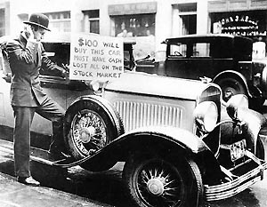
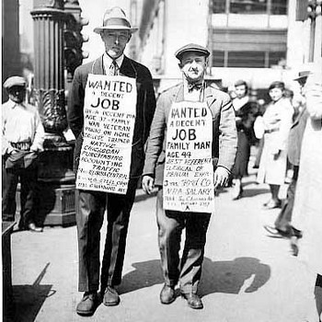
The Global Depression
High Tariffs (______________ on imported goods) raised to “protect” US industry!
Keep money inside country to __________________ from the crash
Result, Europe had to cut back on production, _____________________ ________________ lose jobs!
High Unemployment everywhere! Great Depression goes _____________ !

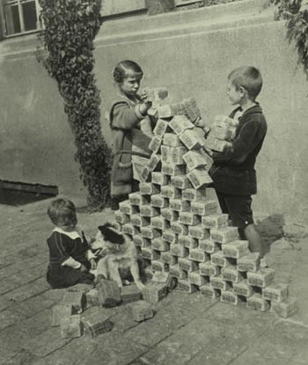
German children playing with worthless Marks
German woman paying for her vegetables with baskets full of Marks
At its worst in 1923, a loaf of bread = 3 Billion Marks…that’s 2 Billion US Dollars!!!

The German Hyperinflation
Germany struggled to pay back the _______________________ of the Treaty of Versailles
Decided to ________________ more money to help pay it back.
Problem: this policy devalued the German currency, creating _________________________________
Result: German money became __________________________________!

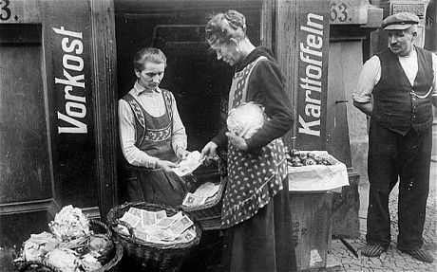

Global Depression – Impacts
Unemployment Rates Rise!
________________________________ countries experienced high unemployment
In the U.S. alone, ____ out of every _____ Americans was without a job during the Global Depression!

World Trade Falls!
_______________ for goods drop in world trade, losing ____________________ and making it harder for __________________________ to pay their workers, which leads to more ________________ in production and jobs!

From Democracy to Totalitarianism!
The ____________________________ weakened western democracies
This gave ________________________________ (citizens under absolute state control) a chance to come to power!
People turned to _____________________ governments to get them out of the Depression!

The Rise of National Socialism (Nazism)
The horrible effects of hyperinflation and the Great Depression on Germany, combined with German ____________________________ towards the Treaty of Versailles, gave the Nazi Party a platform and followers!
The Nazis blamed __________________ bankers and financiers for the global depression.
Anti-Semitism is:

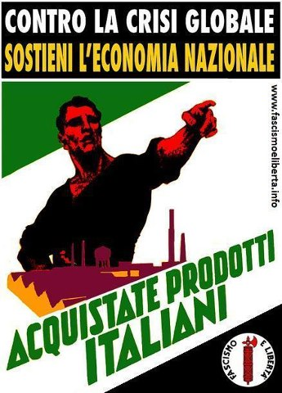
Nazi and Fascist Propaganda
The poster on the left reads “Work and Bread” – urging Germans to vote for the Nazis to recover from the Depression
The poster on the right reads “Counter the global crisis by supporting a nationalized economy. Purchase Italian products!” – urging Italians to stop the Depression by following the fascist control of Mussolini
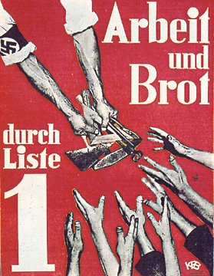

How to be a Dictator:
Step One – Give a good speech!

“The German farmer must be rescued in order that the nation may be supplied with the necessities of life...”
“Within four years unemployment must be finally overcome.”
“The securing of the necessities of life will include the performance of social duties to the sick and aged.”
“May the good will of all others assist in the fulfillment of this our earnest wish for the welfare of Europe and of the whole world.”
“First will come honor and then freedom, and from both of these happiness, prosperity, life: in a word, that state of things will return which we Germans perhaps dimly saw before the War, when individuals can once more live with joy in their hearts because life has a meaning and a purpose, because the close of life is then not in itself the end, since there will be an endless chain of generations to follow!”
- Adolf Hitler, September 1930 (nearly a year after the Stock Market Crash)
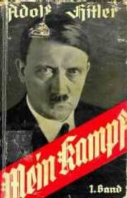
- What are 3 things that the German people would have liked
from this speech?
Published in 1925, Mein Kampf (My Struggle) was Hitler’s book outlining his Nazi political beliefs and ant-Jewish views, blaming the Jews for Germany’s economic problems and calling for the rise of a stronger Germany full of living space (Lebensraum) – the rise of a German empire!

- What is Hitler’s wish and for whom?

- What promises does he make to the German people?

