Causes and leaders of world war ii

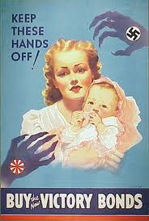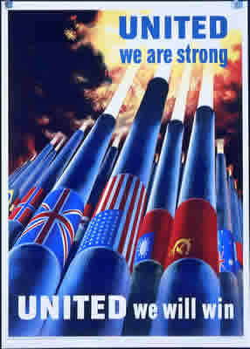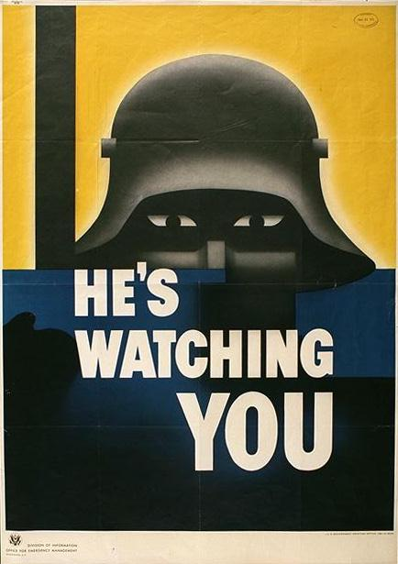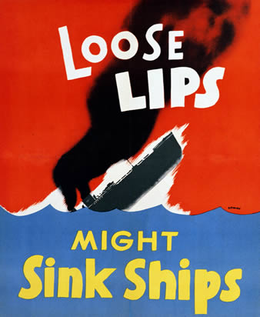

Causes of world war ii:

**Aggression** by the ______________________________ powers of   
Germany, Italy and Japan

* Japan invades ______________________________ & rest of China
* Italy invades _____________________
* _______________________ invades Rhineland, annexes Austria, Czechoslovakia and Sudetenland

**Nationalism –** Dictators use ____________ and ________________ for one’s country in their propaganda and to hold on to power!

**Failures of the ______________________________________________**

* **Left Europe in bad _______________________ conditions and left Germany with _____________________ as they struggled to pay their war reparations!**

**Appeasement – European countries don’t want to go to war after their experiences in ____________________________, so they let __________________ take land in the hopes that he would stop and they would keep the ______________.**

**Tendencies towards ___________________________ and _____________________ (strong anti-war attitudes) in Europe and the United States**

American leaders of World War II

**U.S. Presidents during the War:**

**Franklin Delano Roosevelt**

President at the ________________ of the war.   
 Declares war after the attack on   
_______________ ________________.

**Harry S. Truman**

President after Roosevelt __________. He makes the decision   
to end the war by dropping the _____________ _______________   
on Hiroshima and Nagasaki

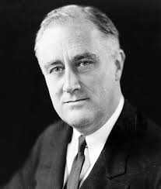

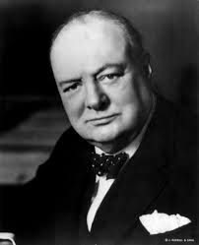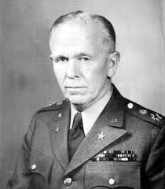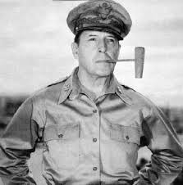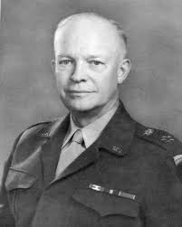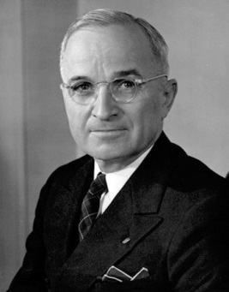

British leader during world war ii

**Winston Churchill**

Symbol of _________________ and his war speeches   
 during the _______________ of ______________   
kept British morale up at home!

American commanders during world war ii

**Dwight D. Eisenhower**

Allied commander in ___________________ and planned   
the _________________ Invasion to free Europe from Nazi Control!

**Douglas MacArthur**

US ____________________ and Allied commander in   
the ________________ that fought the Japanese

**George C. Marshall**

US General and later becomes known for the   
Marshall Plan during the __________ ________